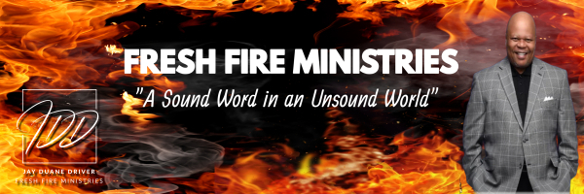

Word Wednesday Bible Study Guide

February 5, 2025

REAL TALK SERIES: “Have You Looked in the Mirror Lately?”

“As in water face reflects face, so a man’s heart reveals the man.” Proverbs 27:19 (NKJV)

I. Subtext
A. James 1:21-25

II. The Reflection of the Word
- I Peter 2:1-3

III. The Reflection of Our Ways
- Psalm 119:59

IV. The Reflection of Our Walk
- Ephesians 5:15

V. The Reflection of Our Work
A. Ephesians 2:8-10

Next Week: “The Believer’s Response to Trump 2.0”

