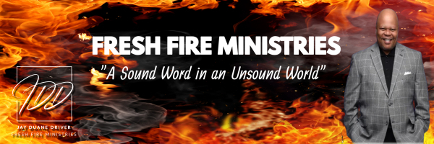

Word Wednesday Bible Study Guide

January 15, 2025

REAL TALK SERIES: “But You Don’t Know What I’ve Done”

“The fool has said in his heart, “There is no God. They are corrupt, They have done abominable works, There is none who does good….” Psalm 14:1-3 (NKJV)

I. Subtext
A. Psalm 103:10-23

II. No Condemnation
- Romans 8:1-3

III. No Incarceration
A. Galatians 5:1-2

IV. No Procrastination
- John 9:4

V. No Separation
A. Romans 8:35-39

Next Year: Real Talk Series: “Why?”

